A/R Search (Hotkey C)

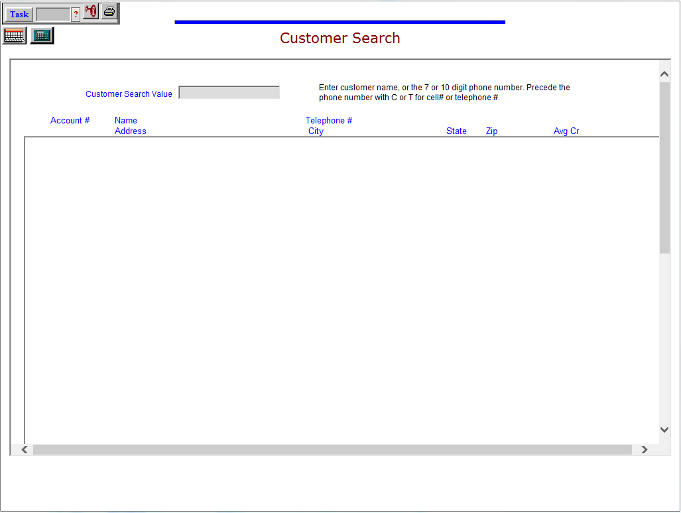

As there are times when you just need a quick bit of information about a customer, there is a hotkey defined to give you this information. Type “C” in the Shortcuts bar to use this look-up function.

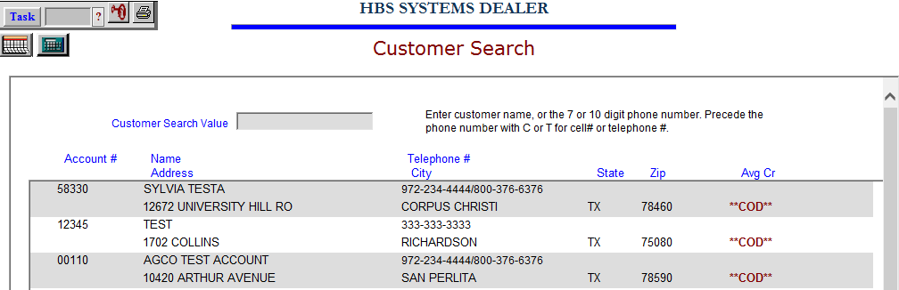

Type in a portion of the customer’s name or the business name. A screen of the closest matches will display. You can use your mouse to scroll through the displayed choices.

You may also search for a customer by their phone number. Type in “T” followed by their primary number to look them up via their telephone number, or “C” followed by their cell phone number to look them up via their cell phone number. These search methods examine your entire customer list to find matching phone numbers.

The information displayed includes:

- Customer Number
- Name
- Phone Number
- Average Credit Rating
- Street Address
- City
- State
- Zip Code
- If the customer is on COD status, this will be noted beside the Zip Code.

This same style of information is present anytime the feature to look up a customer’s number is present.

The information shown is controlled by a setting on the AR defaults screen in Company File Maintenance, using the field Display expanded customer search info. 2 lines needs to be set to “Yes” to display this expanded information. If not, the display is limited to:

- Customer Number
- Name
- City
- State
- Phone Number
- A reference to COD status if appropriate

